Project Documentation

D202 – Agile Team Project

Scrum Team Name: **The Four Horsemen**

Scrum Team Members: **Dale Lochrie, Matt Paul, Neil Asplin, Stalin Fernandes**

Contents

Project Overview 1

[Stated Requirements 1](https://d.docs.live.net/35e3d213d0087911/BICT/Year%202/Software%20Process/Assignment%201/D202%20-%20Agile%20Team%20Project%20Sprint%202.docx#_Toc460787943)

Group Project Setup and Sprint Planning (Sprint Two) 2

Sprint Two Roles: 2

Development Environment 2

Version Control 2

Sprint One User Stories 2

Tasks for Sprint Two 2

Sprint 2 3

Daily Scrum Meeting 1 3

Daily Scrum Meeting 2 3

Retrospective Meeting: 4

Sketch of User Interface 5

Entity Relationship Diagram 6

Sprint Burndown Chart 7

# Project Overview

**Start Date:** 11/08/16

**Release/End Date:** 20/10/16

**Application Use:** To support degree students in planning their study options

**Scrum Team Capacity:** 4

**Project Allocated Hours:** 36 Hours (Including Planning)

**Number of Sprints:** 4

**Sprint Duration:** 6 Hours

## Stated Requirements

* Be designed for use within the lab network, ideally single sign on will be supported so that the user is automatically logged in
* Use a database for backend data storage
* Store all of the courses available in the degree (code, name, description, semester offered, pre-requisite course code, compulsory (Y/N))
* Categorise the courses available by topic area
* Allow the user to enter the courses they have passed (academic history)
* Based on their history, display to the user the courses they are eligible to take
  + Ideally this will be able to be filtered by topic area (e.g. infrastructure courses)
* Allow the user to select a plan of study (select courses for following semesters)
  + You will support the planning of up to four semesters (this will allow a year one student to plan study for the remainder of their degree)
* Allow the user to save the plan of study in a format which is able to be emailed or printed.

# Group Project Setup and Sprint Planning (Sprint Two)

|  |  |  |
| --- | --- | --- |
| Date | Time: | Duration: |
| 11/08/2016 | 9:00am | 3 Hours |
| 25/08/2016 | 9:00am | 3 Hours |

## Sprint Two Roles:

**Product Owner:** Aaron Steele

**Scrum Master:** Dale Lochrie

**Scrum Members:** Dale Lochrie, Matt Paul, Neil Asplin, Stalin Fernandes

## Development Environment

* Microsoft Visual Studio
  + C#
  + ASP.Net
* Microsoft Access

## Version Control

* Git Portable
* GitHub
  + Team Project Repository Created
  + Team Members Invited

We briefly tested Git and became familiar with basic commands.

|  |  |  |
| --- | --- | --- |
| Priority# | User Stories | Story Points |
| #11 | Make the application web based | 30 |
| #01 | As a Student, I would like to login to the application manually | 13 |
| #02 | As a lecturer, I would like all the courses stored with codes and value names. | 5 |
| #03 | As a lecturer, I would like to be able to make changes to paper details. | 30 |
| #04 | As a Student, I would like to enter the courses that I have passed and save my academic history. | 8 |
| #05 | As a Student, I would like to see available future papers, filtered by topic area, based on papers I have already completed. | 8 |
| #06 | As a Student, I would like to be able to select a plan of study for up to four semesters. | 5 |
| #07 | As a student, I would like to be able to save a plan of study in a format that can be emailed or printed. | 8 |
| #08 | As a Student, I would like the application to manage my details. | 8 |
| #09 | As a student, I would like to categorise the courses into topic areas. | 5 |
| #10 | As a Student, I would like to automatically log in, so that I don’t have to log in multiple times. | 13 |
|  | **Total Story Points** | **133** |

## Sprint Two User Stories

## Tasks for Sprint Two

|  |  |
| --- | --- |
| User Story #1 | Points |
| Create Login Page with asp.net | 7 |
|  |  |
|  |  |
| User Story #3 | Points |
| Connect Database to C# project | 4 |
| Lecturer can Make changes to paper | 30 |
|  |  |
| User Story #11 | Points |
| Make the application web based | 30 |

# Sprint 2

**Appointment Time for Sprint Review and Sprint Retrospective Meeting:** 11:30am (8/09/2016)

## Daily Scrum Meeting 1

|  |  |  |  |
| --- | --- | --- | --- |
| Team | What did you do last time? | What will you do today? | Are there any impediments in your way? |
| Neil | Finish off database and got it verified with the project owner. | Researching ASP.net to create the interface | Knowledge of ASP.net , need help researching ASP.net on google |
| Matt | Modify the database | Researching ASP.net and Assisting Stalin with creating the login Page | Will need a hand or some research on integrating the database in ASP.net |
| Stalin | Worked on Unit Testing and integrating database in solution | Create a login page using ASP.net and Connect the database to it. | Might need to research a ASP.net on google to help finish the login screen |
| Dale | Worked on Unit Testing and integrating database in solution | Scrum Master position, gathering documentation. Researching ASP.net and Assisted Neil | More research needs to be done on ASP.net for creating the interface. |
| Did The Product Owner Attend? | YES/**NO** |

## Daily Scrum Meeting 2

|  |  |  |  |
| --- | --- | --- | --- |
| Team | What did you do last time? | What will you do today? | Are there any impediments in your way? |
| Neil | Researching ASP.net to create the interface | Code the lecturer page in ASP.NET. | Learning the ASP.NET framework is slowing me down. |
| Matt | Researching ASP.net and Assist Stalin with creating the login Page | Assist Stalin with finishing the login page. Finish draw a draft of the Student Page | No |
| Stalin | Create a login page using ASP.net and Connect the database to it. | Finish Coding up the login. Make a start on the student page | Learning the ASP.net framework, merging two parts of the same Project together in git. |
| Dale | Scrum Master position, gathering documentation. Researching ASP.net and Assisted Neil | Scrum Master position, gathering documentation.  Draw a draft of the Lecturer page | Getting familiar with ASP.NET but I'm getting their. |
| Did The Product Owner Attend? | YES/NO |

## Retrospective Meeting:

|  |  |  |  |
| --- | --- | --- | --- |
|  | Task status?  (Start doing, stop doing, continue doing) | In hindsight could you have done anything better? | Other Information |
| Neil | User story 3. lecturer to modify course all papers. | No | Still learning ASP.NET |
| Matt | Draw.IO, Student page draft. | No | Still working on draft. Assisted Stalin peer programming. I will become scrum master next week. |
| Stalin | Programmed Login page for both student and lecturer. Started work on student course page | No | Changed fonts on the login page |
| Dale | Scrum Master position, gathering documentation. I was using draw I.O to make the draft of the lecturer page | Put the UCOL image into the draft page. | N/A |
| Did Aaron Attend? | YES/NO |

## Sketch of the Lecturer Interface

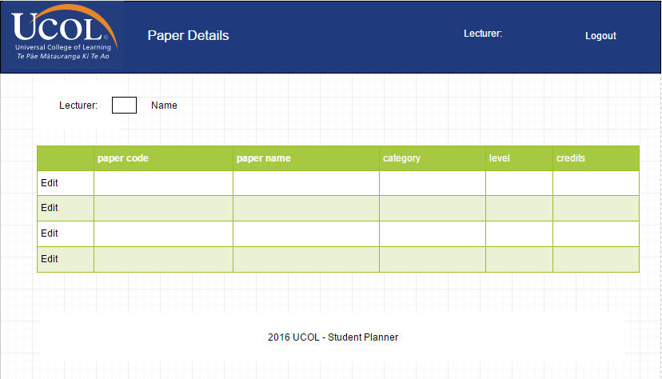

## Sketch of the Login Interface

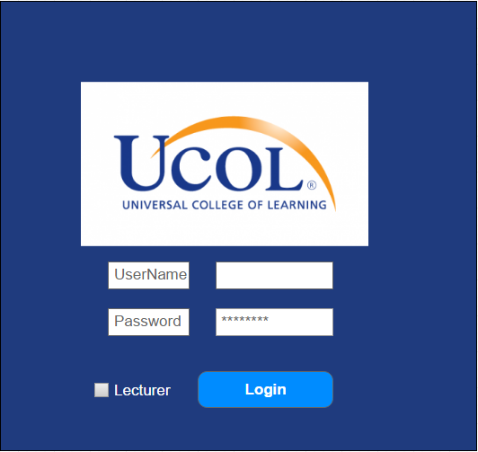

## Entity Relationship Diagram

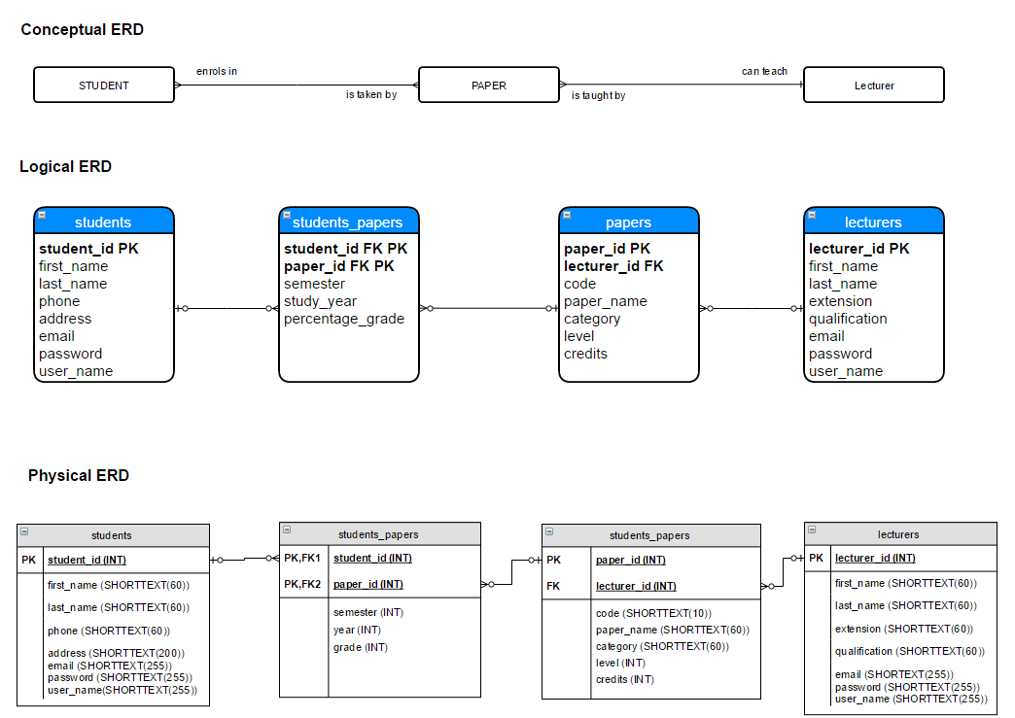

## Sprint Burn down Chart

